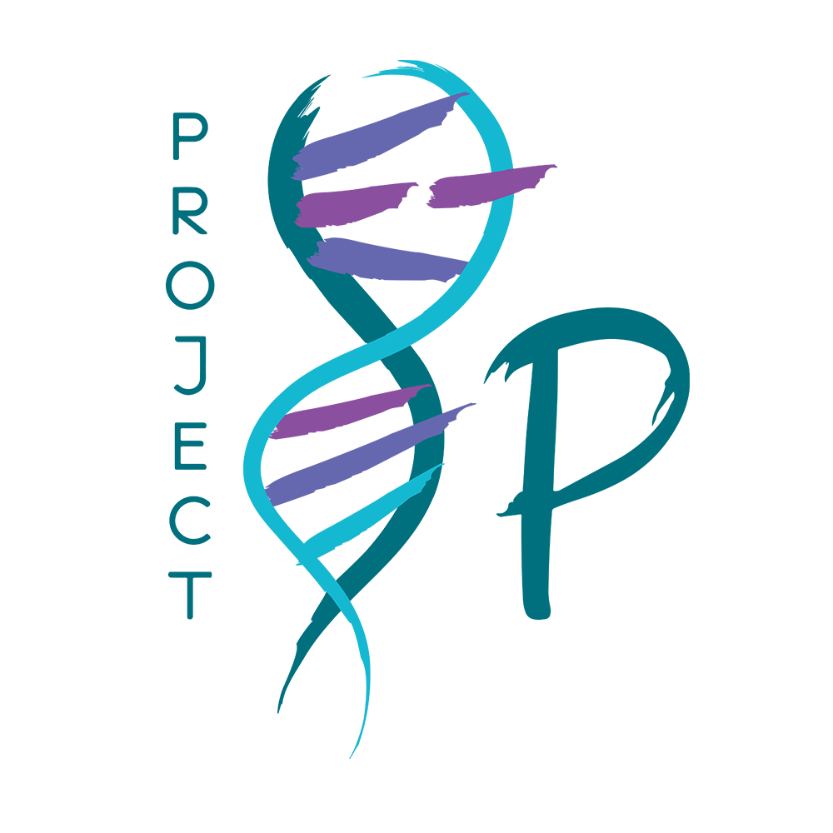

Project 8p
Executive Director

Job Type: Full-time position
Salary: The position is compensated with a base salary that will be commensurate with the candidate's experience.
Location: Remote; preferably based in greater NYC metro/Tri-state area to facilitate regular in-person meetings. Some travel as necessary.

About Project 8p Foundation:
Project 8p Foundation is a nonprofit biotech organization established in late 2018 to research a category of chromosomal disorders affecting the 8th chromosome. 8p disorders are extremely rare, the impact is dramatically negative, and there is no cure or standard course of treatment.
Project 8p is patient-led and takes a collaborative open science approach to research, with a commitment to develop research threads that can be used to develop treatments for 8p disorders and for other complex neurological chromosome diseases.

The Role:
We seek a creative fundraising Executive Director with at least 10 years of work experience to advance medical and science-based initiatives to target, qualify, engage and, with the Board Chair, directly solicit individual, institutional donors and venture philanthropy solutions. In the process, the Executive Director will collaborate with the CEO to engage new Board members and to develop a range of funding and research partnerships.
Reporting directly to the CEO, this position will have both internal and external facing responsibilities. Success will be primarily measured by the ability to grow the fundraising program.
Responsibilities:
In addition to the onboarding materials provided you will be expected to take personal initiative to understand chromosome 8p disorders at a layperson’s level, as well as the current strategic and operating plan of the organization. You will be responsible for reaching the Fundraising target of $3.0 M in the first 12 months.
Leadership and Strategic Planning:
- Partner with the CEO to provide strategic leadership to the organization.
- Maintain overall responsibility, accountability, and authority for the management of day-to-day operations for Project 8p and its programming with the support of staff and the Science Director.
- Develop and implement strategic plans to achieve Project 8p's mission and goals.
- Foster a positive and collaborative organizational culture.
Fundraising, Financial Management and Venture Philanthropy:
- Develop new and execute fundraising strategies to secure financial support for the organization.
- Manage the organization's budget and financial resources effectively
- Seek and cultivate relationships with donors including but not limited to, individuals, foundations, and corporations.
- Structure creative in-kind partnerships or with equity to advance programs (I.e. venture philanthropy that includes high engagement, multi-year support and capacity building).
- Experience or willingness to learn and work with crypto donor models
- Oversee and leverage social media interactions with new or existing donors
Advocacy and Public Relations:
- Advocate for the 8p community at local, national, and international levels.
- Build and maintain positive relationships with key stakeholders, including government agencies, patient groups, and healthcare organizations.
- Manage public relations, social media and communications to enhance the organization's visibility and impact.
Organizational Development:
- Recruit, lead, and develop a high-performing team.
- Implement effective human resources policies and procedures.
- Continuously assess and improve organizational effectiveness.
Board Relations and Governance:
- Work closely with the Board of Directors to align organizational strategy with their vision and goals.
- Provide regular updates to the Board and engage them in key decision-making processes.
- Ensure compliance with legal and ethical standards.
Community Engagement and Education:
- Engage with the 8p community to understand their needs and concerns.
- Develop and implement educational initiatives to raise awareness about 8p.
- Facilitate support groups and events to connect individuals affected by 8p.

Professional Experience:

Skills:
- Self-starter with a proven ability to work independently with minimal oversight while also being a collaborative teammate
- Strong work ethic with an understanding of grassroots organizations
- Takes initiative in bringing new out of the box ideas for finding and cultivating new donors
- Willingness to make cold calls and form relationships by phone, Zoom and other tools
- Superior interpersonal skills including interfacing and engaging diverse volunteer and donor groups as well as collaborating with and motivating board members
- Strong project management and organizational skills including planning, program development and task facilitation
- Transparent and high integrity work style; takes personal responsibility and accountability for work and meets deadlines
Requirements:
- Master’s degree or equivalent
- Highly motivated to work independently and making an impact for a new disease-specific patient-centric foundation
- Collaborative approach, with a strong ability to project manage and get things done (individually and through others) in an expeditious manner
- Excellent and persuasive written and verbal communication skills
- Ability to work in a hybrid model with the expectation to be in NYC several days a month
- Proficiency in Google and Microsoft suite of tools and project management software
- Creativity and personal dynamism

Application Requirements:

- Cover letter
  - Please explain what is compelling to work on a complex rare disease and why you are interested in this position.
  - Please summarize how you meet the skills and requirements for this position.
  - Please provide a writing sample of a grant application
- Resume/CV

Please email to Nancy Dominguez - nancy@project8p.org

While we are a young organization looking to grow rapidly, we strongly encourage all candidates to apply that may fit some criteria, if not all.

Project 8p is an Equal Opportunity Employer. We respect and seek to empower each individual and support the diverse cultures, perspectives, skills and experiences within our workforce.

